Creating a WBS Dictionary
The WBS dictionary, as its name implies, is a dictionary that defines each work package in the WBS.
You’ll use the WBS dictionary to clearly identify what the components (elements) of the WBS are and how they relate to the project scope

- Code of accounts number
(let’s pretend it’s been assigned a project code of 507 in your organization). 507.1 Database
507.2 Network
507.3 software
507.4 Hardware
* 507.1 Databse
> 507.1.1 old information about corona virus
> 507.1.2 new information about the virus is changing rapidly
* 507.2 Network
> 507.2.1 Router
+ 507.2.1.1 huge cables
+ 507.2.1.2 Server
+ 507.2.1.3 WIFI
> 507.2.2 Swich
> 507.2.3 WAN
+ 507.2.3.1 LAN
- 507.2.3.1.1 many computers
- 507.2.3.1.2 cables
*507.3 software
> 507.3.1 programmers
> 507.3.2 A program that performs CT scans for each person
+ 507.3.2.1 Mechanism to determine whether a person is infected or not
> 507.3.3 A program that determines the number of infected people in the hospital room
* 507.4 Hardware
> 507.4.1 engineers
> 507.4.2 Metal
> 507.4.3 electronic board
> 507.4.4 glass
>507.4.5 electrical wires and cables

- Description of the WBS element
507.2 Network
Gathering valuable information about Covid-19 and use it as a database and a foundation for our product.
507.3 software
Developing the software of our product.
507.4 Hardware
Designing and building the physical side of our device "Hardware
507.1 Databse
Gathering valuable information about Covid-19 and use it as a database and a foundation for our product.

3.Person, or other organization responsible for the WBS element
We are responsible for selecting the most qualified engineers, staff and programmers with the highest efficiency to complete the project in a timely manner, in addition to the project manager and the people responsible for the project. We have the necessary tools to complete the project, including devices, programmed objects for the project, sensor and sensitive software chips needed for the project

4.Resources required to create the WBS element (resources are people, materials, and facilities)
And we followed some reliable sources to perform the project with complete accuracy from tangible events, books and old and new sources, provided that we choose the most valuable information for the project. From modern programming languages in addition to the previous experiences of some experts in the scientific and programming field, and based on some modern Western scientific facts and based on some of the foreign sources

5. Cost to create the WBS element

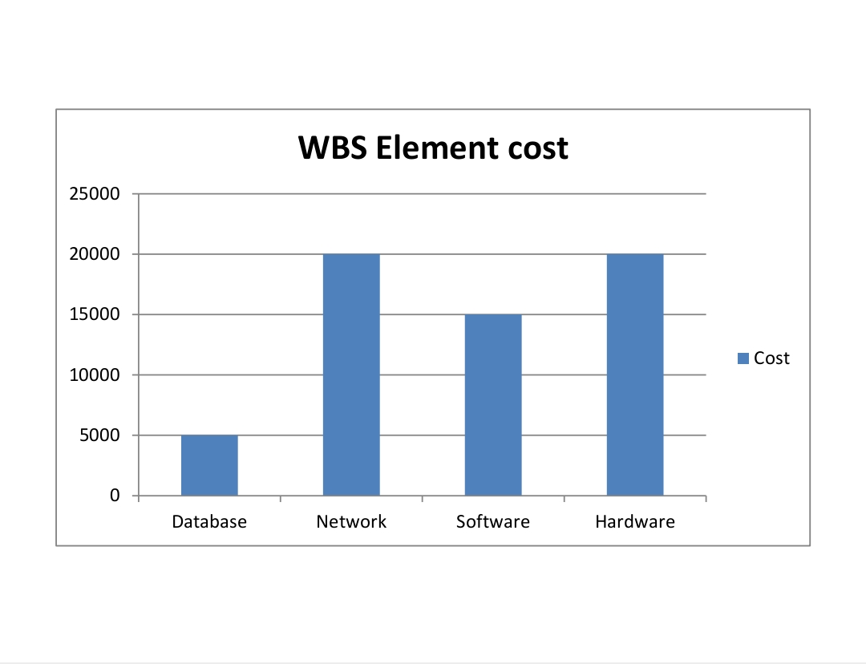

6.Criteria for acceptance of the specific deliverable
1-The product works efficiently and there are no errors in operation or control
2-It should be easy to use to avoid human errors
3- Ensure that the device does not negatively affect the environment

7.Milestone schedule

November: We will collect the database for our project
Such as
- old information about corona virus
- new information about the virus is changing rapidly
December: We will make the network for the project using the data .
January: we will make a program that performs CT scans for each person and Mechanism to determine whether a person is infected or not and a program that determines the number of infected people in the hospital room.
April: We will collect the tools that we will use it to do our work
Such as electrical wires and cables, metals , glass …

